Parameter | Image A (Before):  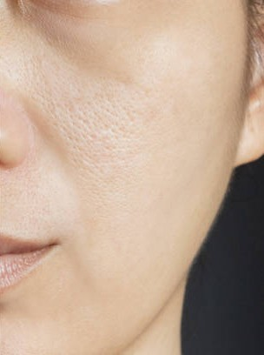 | Image B (After):  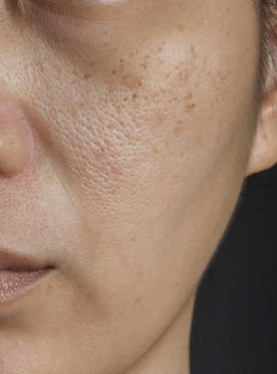
Input Image | Face with enlarged pores | Face with enlarged pores and visible dark spots
Visible Skin Condition | Enlarged pores with no significant pigmentation | Enlarged pores with noticeable dark spots/pigmentation
Predicted Skin Type | Oily | Oily
Skin Type Confidence | 87.68% | 97.68%
Predicted Skin Concern | Pores | Dark Spots
Skin Concern Confidence | 74.13% | 87.88%
Model Interpretation | The model identified enlarged pores as the dominant skin concern while classifying the skin type as oily. | The model correctly detected dark spots as the dominant concern while consistently classifying the skin type as oily.
Overall Observation | Correctly recognized oily skin with enlarged pores. | Correctly recognized oily skin and shifted the primary skin concern to dark spots due to the visible pigmentation.
JSON output | {  "message": "Analysis successful and saved to database",  "id": "6a5ce88840ea194b327dac1f",  "analysis": {  "skin_type": {  "prediction": "Oily",  "confidence": 0.8768,  "all_probabilities": {  "Combination": 0.0002,  "Dry": 0.1154,  "Normal": 0.0075,  "Oily": 0.8768,  "Sensitive": 0.0002  }  },  "skin_concerns": {  "prediction": "pores",  "confidence": 0.7413,  "all_probabilities": {  "Normal": 0.004,  "Redness": 0.0005,  "dark spots": 0.1689,  "inflammatory acne": 0.0006,  "non inflammatory acne black heads": 0.0031,  "non inflammatory acne white heads": 0.0007,  "pigmentation": 0.0161,  "pores": 0.7413,  "wrinkles": 0.0649  }  }  }  } | {  "message": "Analysis successful and saved to database",  "id": "6a5ce86040ea194b327dac1e",  "analysis": {  "skin_type": {  "prediction": "Oily",  "confidence": 0.9768,  "all_probabilities": {  "Combination": 0.0001,  "Dry": 0.0218,  "Normal": 0.0012,  "Oily": 0.9768,  "Sensitive": 0  }  },  "skin_concerns": {  "prediction": "dark spots",  "confidence": 0.8788,  "all_probabilities": {  "Normal": 0.0002,  "Redness": 0.0001,  "dark spots": 0.8788,  "inflammatory acne": 0.0033,  "non inflammatory acne black heads": 0.0159,  "non inflammatory acne white heads": 0.0008,  "pigmentation": 0.0484,  "pores": 0.0443,  "wrinkles": 0.0083  }  }  }  }

